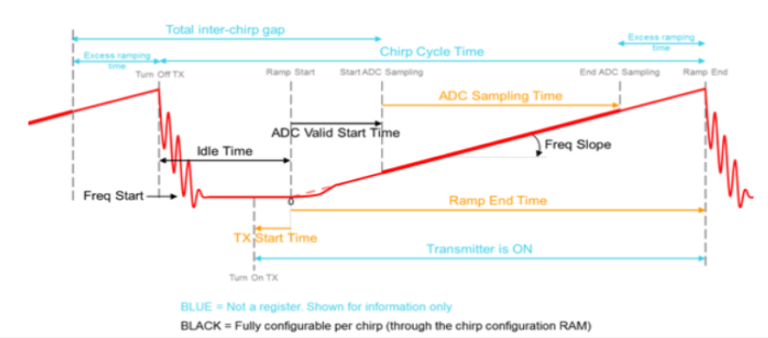

|  |  |  |
| --- | --- | --- |
| Item | Value | Comment |
| Start Frequency | 77GHz |  |
| Idle Time | 2us |  |
| Ramp End Time | 27.56us |  |
| ADC Valid Start Time | 1.66us | In complex 2X mode |
| ADCFs | 20MHz |  |
| IF Bandwidth | 9MHz | 0.9*ADCFs/2 in complex 2X mode |
| NFast | 512 |  |
| ADC Sampling Time | 25.6us | NFast/ADCFs, valid FMCW dwell time in one PRI |
| Inter Chip Time | 3.96us | Idle Time + ADC Start Time + Excess Ramping TIme |
| PRI | 29.56us | Idle Time + Ramp End Time or ADC Sampling Time + Inter Chip Time |
| Slope | 29.306MHz/us |  |
| Bandwidth | 750MHz | ADC Sampling Time * Slope |
| Range Resolution | 0.2m | $$\frac{c}{2B}$$ |
| Maximum Unambiguous Range | 46 | $$\frac{2R_{un}}{c}*Slope=\frac{0.9ADCFs}{2}⟹ R_{un}=\frac{0.9ADCFs}{2}\frac{c}{2}\frac{1}{Slope}$$ |
| NPRI | 128 |  |
| CPI | 3.784ms | NPRI * PRI |
| Velocity Resolution | 0.515m/s or 1.854kph or 1.152mph | $$\frac{1}{CPI}={∆f}_{D}=\frac{2∆v}{λ}⟹ ∆v=\frac{c}{f}\frac{1}{2}\frac{1}{CPI}$$ |
| Maximum Unambiguous Velocity | 32.95m/s or 118.62kph or 73.708mph | $$\frac{1}{2PRI}=f_{Dun}=\frac{2v_{un}}{λ}⟹ v_{un}=\frac{c}{f}\frac{1}{2}\frac{1}{2PRI}$$ |
| Frame Periodicity | 10ms |  |